Exercise 2

Organic Objects

This is the soil from my garden. You can see in the picture the different rocks and fertilizers used giving it a bumpy texture if you actually touched it.

This is my drive to Utah. You can see the texture of the hill with all the rocks and dark spots.

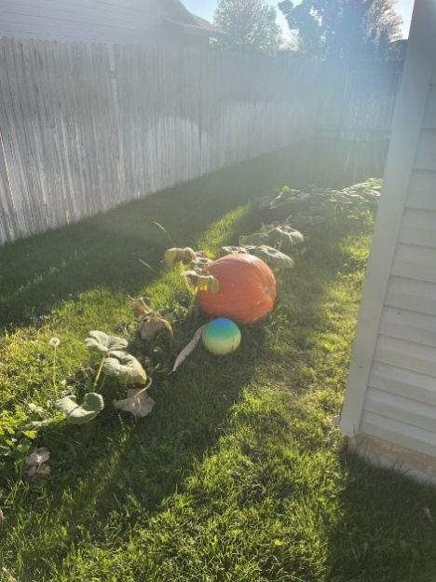 This is grass, The texture of the grass is shown with it going in different dirrections

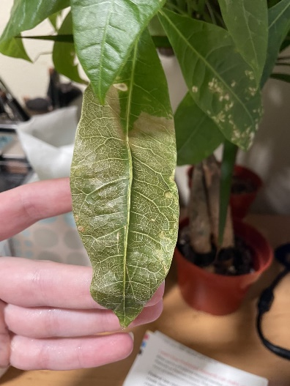 This is my dead leaf on my plant, you can physically see the lines in the leaf and the one in the middle would indicate that there is a bump in the middle.

The clouds in this picture are an organic implied texture. From the picture you can tell the clouds are fluffy.

Mechanical Objects

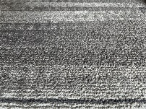 This is the carpet in my room. The irregular shapes help show to the texture.

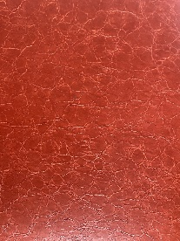 This is a picture of the material from the ottoman I found. With the individual lines in the material you can imagine running your hand over it and it feeling bumpy.

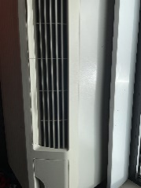This is an air conditioner vent and you can see that there or slits going into it where it is marked with black.

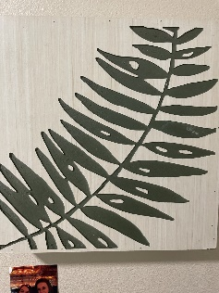 This is a decoration in my room. If you look closely with the green you can see the unevenness of the color and the color is actually engraved into the wood. This is the physical texture.

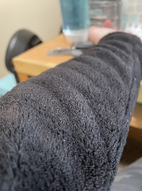 My jacket sleeve. With the angle taken in the picture in the front you can see each individual piece of fluff, as it goes further it starts to blur together and the detail is less.

Exercise 3

Drawing

In this drawing there are many textures used. The texture of the pencil in the background gives the effect that the woman is the center point. All through out the pencil is used and it does not color in the drawing but makes extremely small lines. This texture is definitely effective because it makes the drawing pop.

Photograph

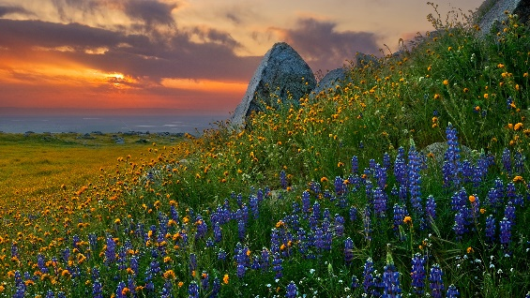 This photo uses atmospheric perspective. In the front you can see the different details on the flowers and the grass, but as it goes farther the grass in the background blurs together and you can’t see the individual details. This is a dominant part. It makes the flowers show it is the main point.

Painting

This painting has the ruffles of the dress painted on to have the illusion that it’s fluffy or real fabric like. This would be implied texture. The detail around the gold picture frame has detail to show the texture of the pattern. The textures around are important and make the painting look realistic.

Ceramics

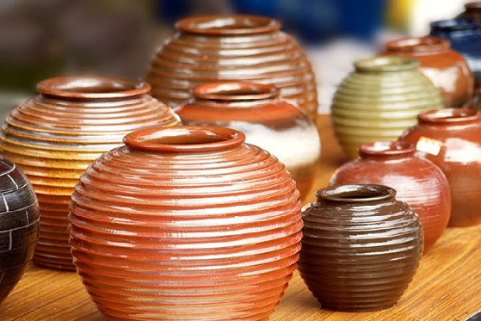 This picture shows multiple pieces with the same texture on the side. The texture is bumpy and ribbed. The texture makes it unique and different from the usual piece.